Performance Testing
Functional Testing of the Leave Module
Date | 24-10-2026
Team ID
Project Name | StaffSync

Test cases
Test | Action | Expected result | Result
TC-1 | Employee applies for a leave | Message "Leave request submitted" and request shows as Pending | Pass
TC-2 | Employee applies for dates that overlap an existing request | Request rejected with an overlap message | Pass
TC-3 | HR opens the Leaves page | All employee requests are visible with Approve and Reject buttons | Pass

Screenshot 1: Employee applies for leave (TC-1)
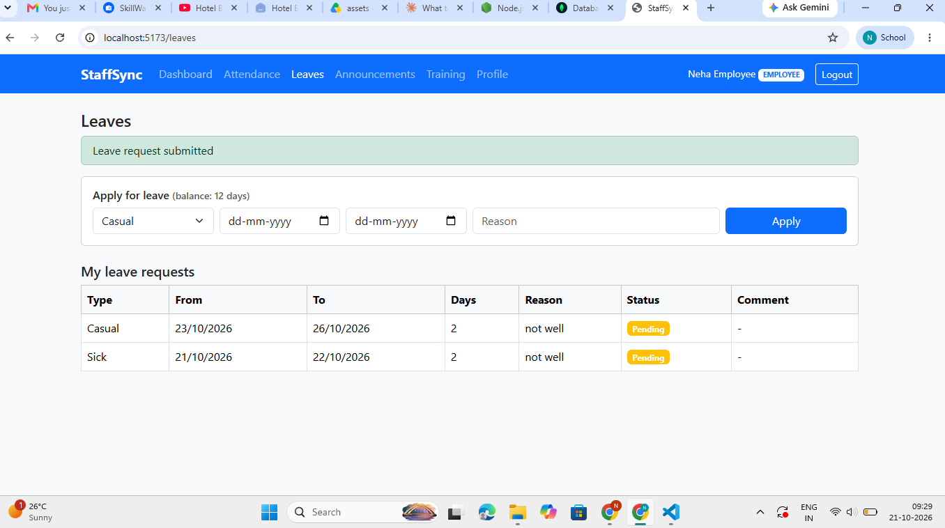

Screenshot 2: Overlapping leave dates rejected (TC-2)
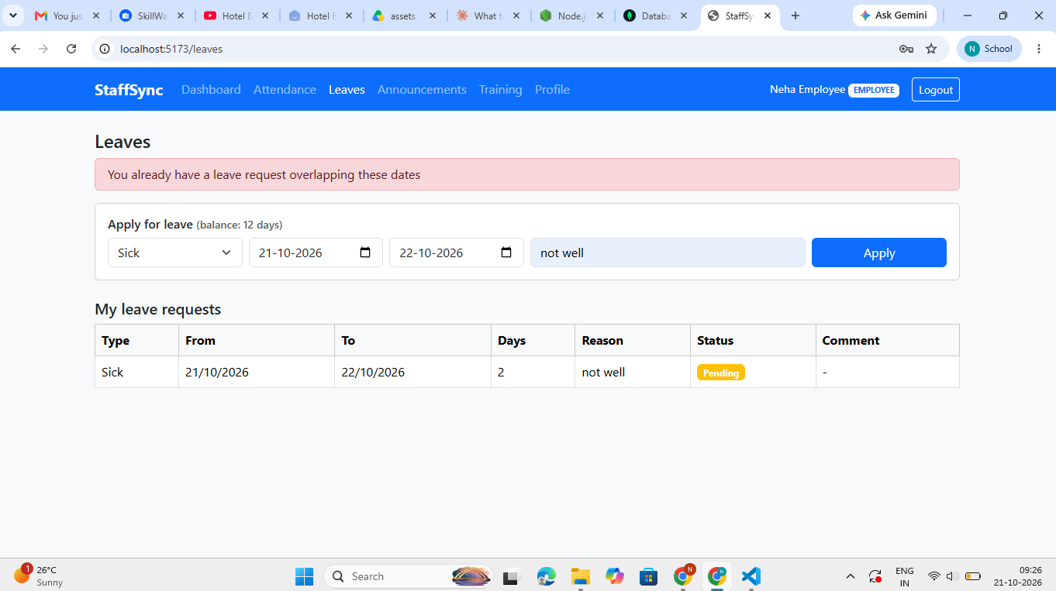

Screenshot 3: HR view of all leave requests (TC-3)
